**Enterprise Resource Planning**

**Training User Manual**

**VERSION 12.0.0**

**HR & Payroll**

* **HR & Payroll**
  + **HR Development (HRD)**
  + **Attendance Information**
  + **Payroll**
  + **GL Transfer**
  + **Reports**

# HR Development (HRD)

## Personnel Info

|  |  |
| --- | --- |
| **Step 1** | Open System **>** HR & Payroll  **>** HR Development (HRD**) >** Personnel Info |
| **Step 2** | Write Personnel Name, Grade, Department, Joining & Birth date etc. |
| **Step 3** | Click **Add** |
| **Step 3** | Click **Modify** button to modify the personnel details |
| **Result** | A new personnel added. |

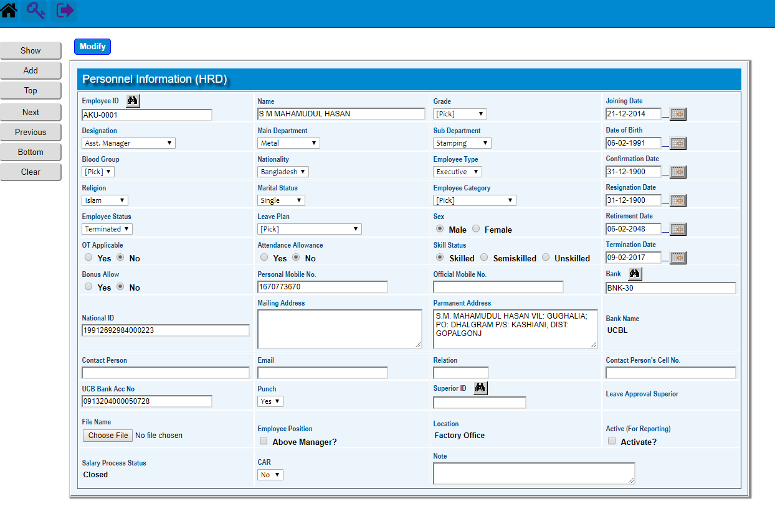

## Image Upload

|  |  |
| --- | --- |
| **Step 1** | Open System **>** HR & Payroll  **>**  HR Development (HRD > Image Upload |
| **Step 2** | Press  [**Image Upload (Link)**](http://107.167.184.219:8080/zab/login?screen=pdpicupload&option=Image+Upload&menuname=pdhrd) to upload personnel Image from Image Location |
| **Step 3** | Press [Personnel Information (HRD) (Link)](http://107.167.184.219:8080/zab/login?screen=pdpicupload&option=Image+Upload&menuname=pdhrd) of Personnel Info |
| **Result** | Image Of the personnel uploaded. |

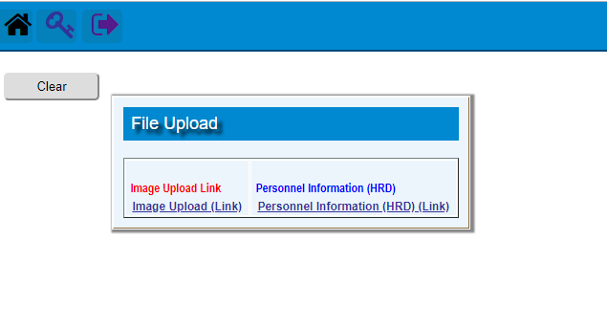

**Setting The HR Development (HRD) Codes & parameters**

|  |  |
| --- | --- |
| **Step 1** | Open System **>** HR & Payroll  **>** HR Development (HRD > Setting |
| **Step 2** | Open the Desired Screen to set the required Code / Parameter |
| **Result** | Desired Code / Parameter will be Set. |

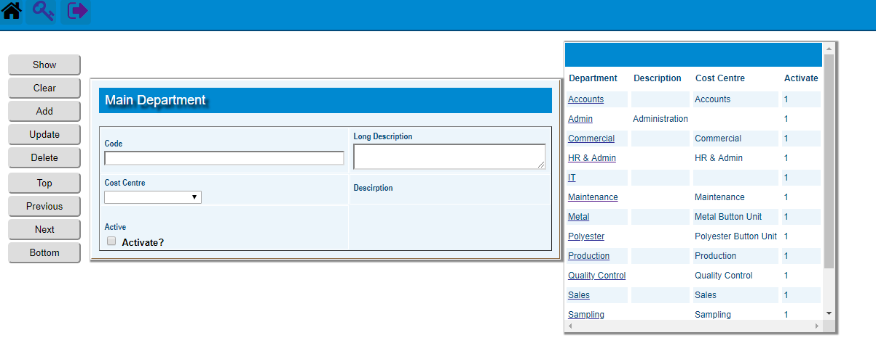

# Attendance Information

## Attendance File Upload

|  |  |
| --- | --- |
| **Step 1** | Open System **>** HR & Payroll  **>** Attendance Information > Attendance File Upload |
| **Step 2** | Choose File Name & Click **Add** |
| **Step 3** | Press link to upload the File |
| **Result** | The Attendance File Uploaded. |

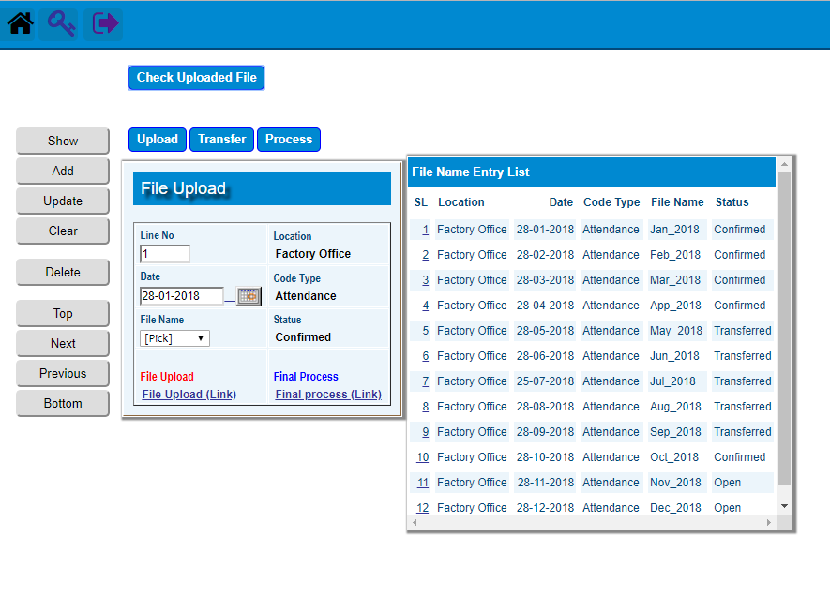

## Attendance Info Update

|  |  |
| --- | --- |
| **Step 1** | Open System **>** HR & Payroll  **>** Attendance Information > Attendance Info Update |
| **Step 2** | Choose Employee ID |
| **Step 3** | Write year, period, days, leave etc. |
| **Step 4** | Click **Add** and then **Update** to update info. |
| **Result** | Requested Attendance Info will be updated. |

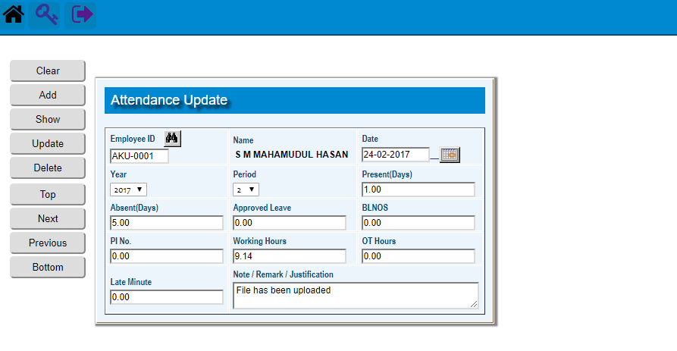

## Attendance Process

|  |  |
| --- | --- |
| **Step 1** | Open System **>** HR & Payroll  **>** Attendance Information > Attendance Process |
| **Step 2** | Choose Process Date |
| **Step 3** | Click **Process**. |
| **Result** | Date wise Attendance process completed. |

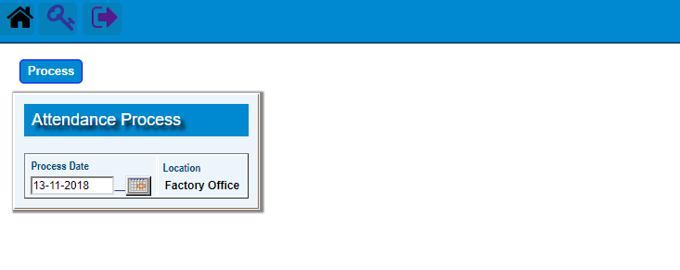

# Payroll

## Personnel Info

|  |  |
| --- | --- |
| **Step 1** | Open System **>** HR & Payroll  **>** Payroll **>** Personnel Info |
| **Step 2** | Write Personnel Name, Designation, Department, Bank Acc. etc. |
| **Step 3** | Click **Add** |
| **Step 3** | Click **Salary Detail** button to add the Component Types of salary |
| **Result** | A new personnel info for Payroll will be added. |

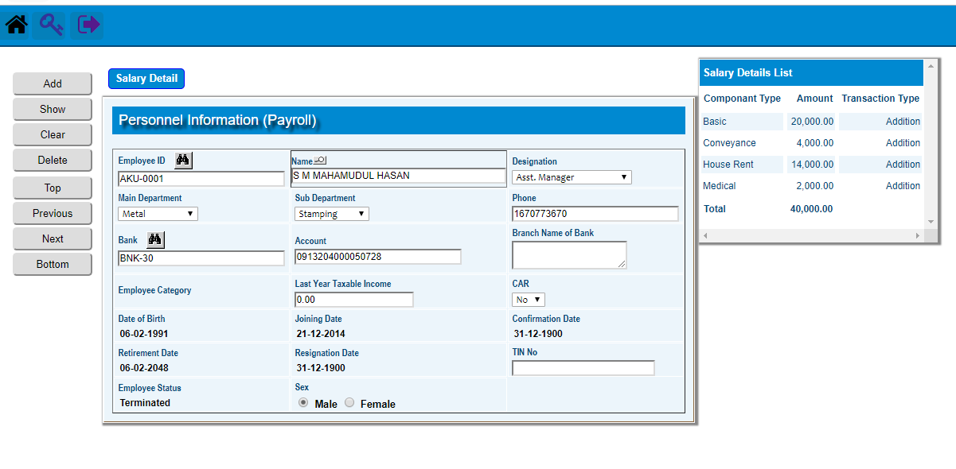

## Loans & Advance entry

|  |  |
| --- | --- |
| **Step 1** | Open System **>** HR & Payroll  **>** Payroll **>** Loans & Advance Entry |
| **Step 2** | Select Employee ID |
| **Step 3** | Write the Loan type, Amounts , Effectivity Date etc. |
| **Step 4** | Click **Add** |
| **Step 4** | **Make Schedule** & add **Schedule Detail** for the Loan |
| **Result** | A new Loan Entry will be Added. |

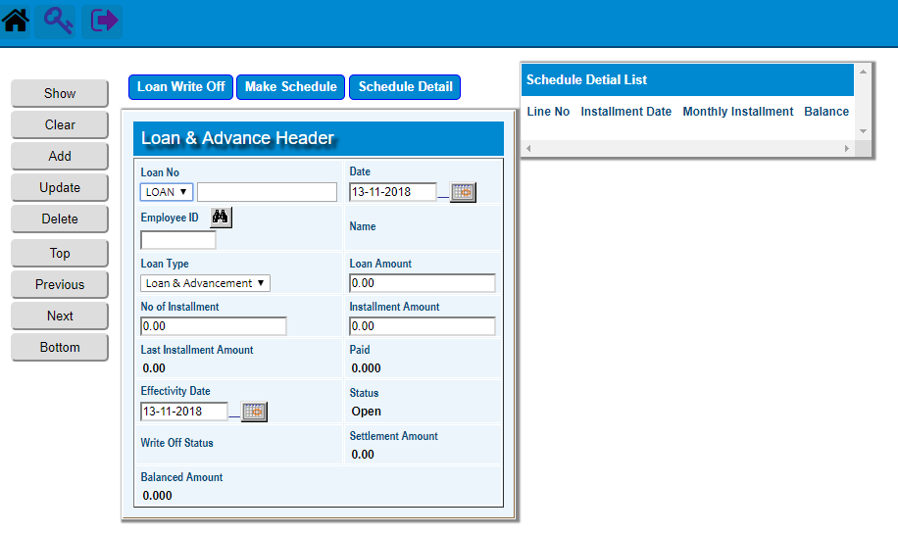

## Transaction Entry

|  |  |
| --- | --- |
| **Step 1** | Open System **>** HR & Payroll  **>** Payroll **>** Transaction Entry |
| **Step 2** | Select Date & Transaction Type |
| **Step 4** | Click **Add** |
| **Step 4** | Click **Detail** Buttonto add transaction details |
| **Result** | A new Transaction of Payroll Entry will be Added. |

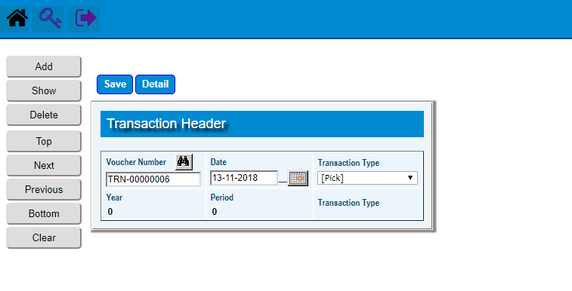

## Salary & Other Process

|  |  |  |  |
| --- | --- | --- | --- |
| **Step 1** |  |  | Open System **>** HR & Payroll **>** Payroll **>** Salary & Other Process |
| **Step 2** |  |  | Select a Process option. |
| **Step 3** |  |  | Select the start ID, end ID & other fields (Year, Period) to make process. |
| **Step 4** |  |  | Click **“Process”** button to execute the desired process. |
| **Result** |  |  | The process will be executed. |

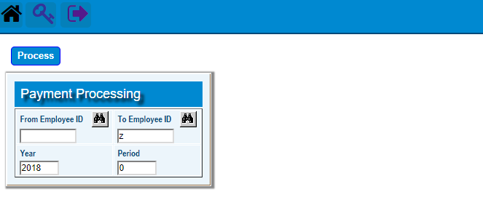

# GL Transfer

## Payroll to GL Transfer

|  |  |
| --- | --- |
| **Step 1** | Open System **>** HR & Payroll  **>** GL Transfer |
| **Step 2** | Select first Year , Period & Posting date |
| **Step 4** | Press the button ***Final Run*** |

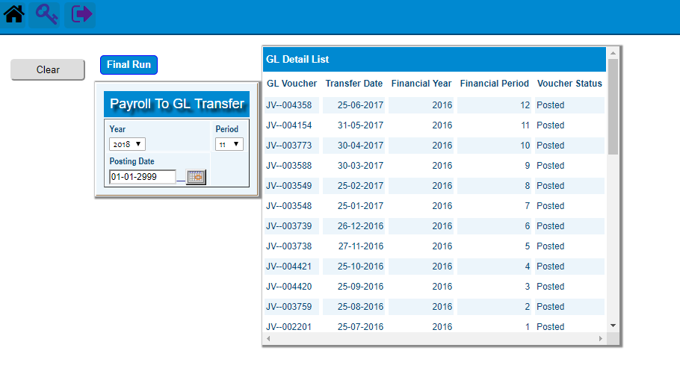

# Reports

### Printing report to preview data

|  |  |  |  |
| --- | --- | --- | --- |
| **Step 1** |  |  | Open System **>** HR & Payroll **>** Reports |
| **Step 2** |  |  | Select a report option. |
| **Step 3** |  |  | Select the start date, end date & other fields to specify data previewing in the report. |
| **Step 4** |  |  | Click **“View Report”** to preview in print format. |
| **Result** |  |  | The report is previewed in print format. |

